HELP WANTED

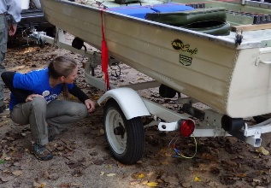
EAGLE SPRING LAKE MANAGEMENT DISTRICT IS LOOKING FOR PERSONS AGES (14 and up).
You will be working at the public boat launch for our Clean Boats/Clean Waters Program. You will be welcoming boaters as they come to use the boat launch, checking boats and trailers for invasive species, asking a brief set of questions, and educating the public on local ordinances. When not interacting with lake users you may be expected to do other chores, i.e., light clean up, etc.
This job would require you to be available on weekends and holidays from May 2 through September 7, 2026 from 8:00am to 4:00pm, although not every weekend and holiday will be required. There may be a few days when we start as early as 6:00am (i.e. opening day of fishing season). You will be scheduled to work for half days, not the entire day, unless you request otherwise. In prior years we were primarily staffing with young people and we are now hoping to involve adults as well.
No experience necessary; we will train you and initially pair you up with an experienced person.
The Eagle Spring Lake Management District is offering an hourly rate of $14.00.
If you would like more information or an application - please call Gina at (262) 594-3583 or you can email us at admin@eaglespringlake.us.

